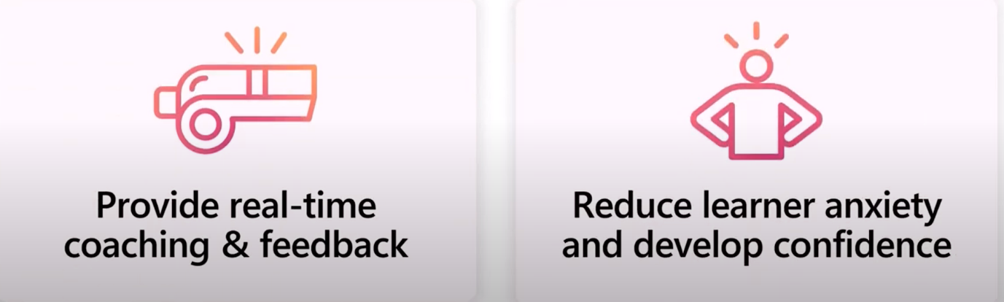
‘Mock’ interviews

For Year 11 students preparing for college interviews in England, it's essential to anticipate common interview questions that allow them to showcase their strengths, interests, and readiness for further education. Here are five of the most important questions they are likely to encounter, along with tips on what interviewers are looking for in their responses . . .

1. Why do you want to study this course?
What they’re looking for: Interviewers want to see a genuine interest and motivation for the course. They’re assessing whether the student has done some research into the subject and understands the course content.
Preparation tip: Encourage students to talk about specific subjects or topics they enjoy and how the course aligns with their goals or aspirations. Mentioning any related experiences or projects can make their answer even stronger.

2. What are your career aspirations?
What they’re looking for: Colleges want to know if students have thought about their future goals and how this course will help them achieve these. Even if they’re unsure, they should show a proactive attitude towards exploring their options.
Preparation tip: If students have a clear career path in mind, they should explain how the course supports that. If they’re unsure, they can mention a few fields of interest and how the course provides flexibility for future decisions.
3. What are your strengths and weaknesses?
What they’re looking for: This question tests self-awareness. Interviewers want to see that students understand their own strengths and can acknowledge areas for growth. They’re also interested in how students work to overcome challenges.
Preparation tip: Students should focus on one or two strengths relevant to the course (e.g., strong in sciences, good time management). For weaknesses, they should pick something manageable and describe the steps they’re taking to improve it.

4. How do you handle challenges or setbacks in your studies?
What they’re looking for: This assesses resilience and problem-solving skills, which are important in independent study settings. Colleges look for students who can stay motivated, seek help when needed, and learn from difficult experiences.
Preparation tip: Students should share an example of a challenge they faced (like a difficult topic or a lower-than-expected grade) and describe how they overcame it, perhaps by seeking help from teachers, improving study habits, or persevering.

5. What do you enjoy doing outside of school?
What they’re looking for: This question explores students’ interests and helps interviewers see them as well-rounded individuals. Colleges look for students with positive hobbies or extracurricular activities that contribute to personal growth and time management.
Preparation tip: Students should mention any hobbies, clubs, sports, or volunteer work they’re involved in, highlighting any skills or values these activities help develop, such as teamwork, discipline, or creativity.

